|  |
| --- |
| Wearable Medical Device Data Ingestion and Analysis Software Requirements Specification |
| CPE 656/658 Software Studio |
| Timothy R. Wilkins  Whit J. Sisulak  Glen L. Riden  James J. Duggan IV |

9/14/2015

Contents

1 Introduction 1

1.1 Purpose 1

1.2 Scope 1

1.3 Definitions, Acronyms, and Abbreviations 2

1.4 References 2

1.5 Overview 2

2 Overall Description 2

2.1 Product Perspective 2

2.2 Product Functions 2

2.3 User Characteristics 2

2.4 Constraints 2

2.5 Assumptions and Dependencies 2

3 Specific Requirements 3

3. Functional Requirements 3

3.2 Non-Functional Requirements 5

Appendix A: Use Case Specifications 6

Appendix A: Use Cases 6

Appendix B: Sequence Diagrams 9

Requirements Specification

# Introduction

## Purpose

The purpose of this document is to define the software requirements specification for Wearable Medical Device software projects. In addition, this document describes the scope, design constraints, and interfaces of the system. The intended audience for this document includes system developers, testers, customers, and any other stakeholders.

## Scope

In the sections below an overview will be given for the two pieces of software that will be required to fulfill the requirements proposed by our customer.

### Data Collection

The data collection portion of this project will consist of the following. There are two different medical devices to be used for this project that record various types of data. The data provided by these devices consists of different file formats, and the data is different from device to device. The software will have to determine the contents of each file and how to process them. Due to how long data transfers take to download the data from a device, there may be a need to convert the data from a binary format to another format in order to speed up the process of getting data off the device. The software needs to able to take in files provided by the medical devices and be able to translate them in a way where they can be stored in a database. The software needs to run in the background of a PC and wait for files that need to be processed. The software will have to interact with a database to insert the data that has been processed in order for the data to be stored for later analysis. The software should allow for some basic configuration such as designating a folder on the PC to be a listener. Files moved or copied into this folder will be processed by the software when they are added. The software should have the ability to process multiple files if more than one is placed into the processing folder at a time.

### Data Analysis

Data analysis software needs to be created to analyze the data that is captured from the data collection tool mentioned above. This piece of software will be a separate stand-alone web application. The software needs to perform data analysis over different intervals of time such as one week, one month, etc. There will need to be some way to manage user access to the various medical data that has been inserted into the database that this software will access. Below are some proposed data analysis ideas that can be incorporated into the project.

* Simple Moving Average
* Data correlation discovery between the multiple devices.
* Possibly determine when an individual moves from walking to running or simply being able to identify the activities that were being performed while the data was being captured.

The data analysis possibilities will likely not fully be realized until the project team understands the different types of data that are available. Also, there will need to be collaboration with the customer for additions or changes to the data measurements provided by this software. The web application will have to have different levels of user access which will be defined later in this document.

## Definitions, Acronyms, and Abbreviations

## References

* IEEE Recommended Practice for Software Requirements Specifications (IEEE Std 830-1998)
* Microsoft Secure Passwords (https://www.microsoft.com/security/pc-security/password-checker.aspx)

## Overview

The remainder of this requirements specification document addresses specific system requirements, constraints, and design specifications, as well as process plans and methods for the requirements specifications team.

# Overall Description



## Product Perspective

## Product Functions

## User Characteristics

## Constraints

## Assumptions and Dependencies

# Specific Requirements



## Functional Requirements

### The system shall provide user authentication.

#### The system shall require unique usernames for each registered user.

##### Each username shall consist of lowercase characters (a through z), uppercase characters (A through Z) and numbers (0 through 9).

#### The system shall require a valid email address.

##### The system shall send out a verification email to the user's email address after registration.

###### The verification email shall have a verify email button that when clicked updates the user's account to active.

##### The system shall prevent the user from accessing the system or uploading data to the system until the user's email address has been verified.

##### The system shall require an admin user to verify that a user has permission to upload medical data to the database.

#### The system shall require a secure password.

##### The password shall follow Microsoft secure password guidelines.

#### The system shall have the ability to log out of a user's account.

#### The system shall have a utility for retrieving a forgotten username or password.

#### Account creation and management shall only be available through the website not the data collection tool.

### The system shall provide the ability to process medical device data files.

#### The system shall provide the ability to select a directory to process files or a single file.

#### The system shall provide the ability to drag and drop files into the tool for processing.

#### The system shall not process data that is not medical data.

##### The system shall only process medical data from the Zephyr and BasisPeak devices.

#### The system shall process medical data from the Zephyr Device.

##### The system shall process Zephyr ECG data.

##### The system shall process Zephyr Heart Rate RR interval data.

##### The system shall process Zephyr Accelerometer data.

##### The system shall process Zephyr Breathing BB interval data.

##### The system shall process all data provided by the Zephyr summary report.

##### They system shall process .csv and .dat files provided by the Zephyr device.

#### The system shall process medical data from the Basis Peak Device.

##### The system shall process all the data provided by the Basis Peak summary report.

##### The system shall process the .csv file provided by the Basis Peak device.

### The system shall connect to a database.

#### The system shall upload processed data to a database.

#### The system shall provide an error message if the connection to the database is unsuccessful.

#### The system shall prompt for user log in when attempting to upload data to the database.

### The system shall be installed with a setup executable script.

#### The installation shall prompt the user for an installation path.

##### The installation shall provide a default installation path.

#### The installation shall prompt the user for a desktop icon.

#### The installation shall prompt the user for a quick launch icon.

#### The installation shall allow the user to abort the installation process.

#### The software shall have an uninstaller to remove the software from the system.

## Non-Functional Requirements

### The system shall run on Windows Operating Systems

#### The software shall run on Windows 7.

### The system shall use a SQL database.

### The system shall require a server to be connected to a reliable network with an internet connection.

Appendices

# Appendix A: Use Case Specifications

This section represents the use case specifications for the functions defined in the requirements specification for the two pieces of software needed to complete this project.

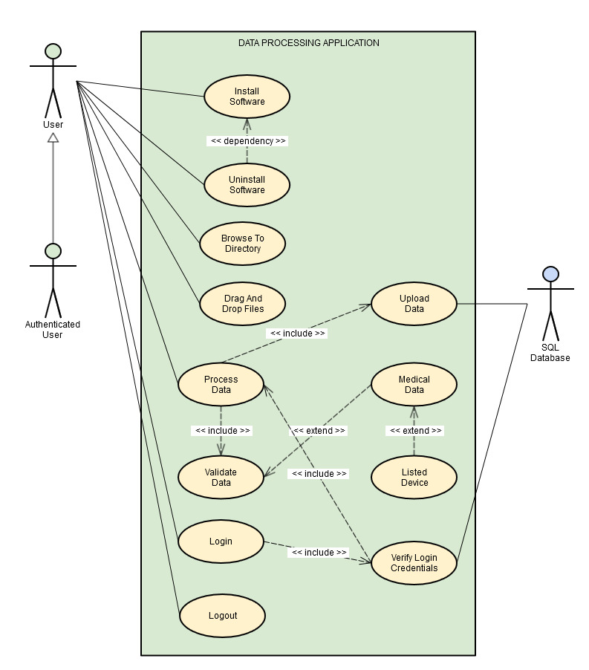

Figure A-1: Use Case Diagram

|  |  |  |
| --- | --- | --- |
| Use Case ID | UC_001 | |
| Use Case Name | Browse to directory | |
| Actor(s) | Users | |
| Purpose | Browse to the location of files to be uploaded | |
| Overview | The user can browse to a file directory location of files to be uploaded | |
| Cross-References | *<requirements to be inserted here after finalized>* | |
| Pre-conditions | The user has access to the software and is authenticated. The user has the appropriate permissions for importing data. | |
| Post-conditions | The files have been selected for processing. | |
| Course of Events | | |
| Actor Actions | | **System Response** |
| 1. User navigates to the directory of files they wish to process | |  |
|  | | 2. The system loads the files. |

|  |  |  |
| --- | --- | --- |
| Use Case ID | UC_002 | |
| Use Case Name | Drag and Drop Files | |
| Actor(s) | Users | |
| Purpose | Drag and drop files to the data collection software be uploaded | |
| Overview | The user can drag and drop files to be uploaded. | |
| Cross-References | *<requirements to be inserted here after finalized>* | |
| Pre-conditions | The user has access to the software and is authenticated. The user has the appropriate permissions for importing data. | |
| Post-conditions | The files have been selected for processing. | |
| Course of Events | | |
| Actor Actions | | **System Response** |
| 1. User selects the files they wish to process and drops them into the console. | |  |
|  | | 2. The system loads the files. |

|  |  |  |
| --- | --- | --- |
| Use Case ID | UC_003 | |
| Use Case Name | Process Data | |
| Actor(s) | Users | |
| Purpose | User initiates file processing | |
| Overview | The user initiates the action to process the loaded files | |
| Cross-References | *<requirements to be inserted here after finalized>* | |
| Pre-conditions | The files have been selected via UC_001 or UC_002. The user has been authenticated and has the appropriate permissions. | |
| Post-conditions | The files are ready to be uploaded in to the database. | |
| Course of Events | | |
| Actor Actions | | **System Response** |
| 1. User initiates the file processing action. | |  |
|  | | 2. The system processes the files. |

|  |  |  |
| --- | --- | --- |
| Use Case ID | UC_004 | |
| Use Case Name | Validate Data | |
| Actor(s) | Users | |
| Purpose | Validate processed data | |
| Overview | The system validates the data being processed based on the device and medical data type. | |
| Cross-References | *<requirements to be inserted here after finalized>* | |
| Pre-conditions | The files have been loaded via use case #1 or #2 and the processing step has been initiated. The user has been authenticated and has the appropriate permissions. | |
| Post-conditions | The files are determined to be valid or invalid. | |
| Course of Events | | |
| Actor Actions | | **System Response** |
| 1. The process data use case initiates the validation of the files. | |  |
|  | | 2. The system validates the files. |

|  |  |  |
| --- | --- | --- |
| Use Case ID | UC_005 | |
| Use Case Name | Upload Data | |
| Actor(s) | Users | |
| Purpose | Upload data into the database | |
| Overview | The software uploads the validated data into the SQL database. | |
| Cross-References | *<requirements to be inserted here after finalized>* | |
| Pre-conditions | The data has been validated and is ready for the upload and the database is online. The user has been authenticated and has the appropriate permissions. | |
| Post-conditions | The data is uploaded into the database. | |
| Course of Events | | |
| Actor Actions | | **System Response** |
| 1. The process data use case initiates the upload of the data | |  |
|  | | 2. The system uploads the data into the SQL database. |

|  |  |  |
| --- | --- | --- |
| Use Case ID | UC_006 | |
| Use Case Name | Install Data Collection Software | |
| Actor(s) | All users | |
| Purpose | Install the data collection software on the system. | |
| Overview | The user needs the data collection software to be installed on the system in order to import data to the SQL database. | |
| Cross-References | *<requirements to be inserted here after finalized>* | |
| Pre-conditions | The system specifications meet the minimum criteria for installation. | |
| Post-conditions | The data collection software is installed. | |
| Course of Events | | |
| Actor Actions | | **System Response** |
| 1. The user runs the set up file for the data collection software. | |  |
|  | | 2. The set-up software appears in a window on the screen. The software requests the user to input a directory to install the software. |
| 3. The user inputs a directory to install the software to. | |  |
|  | | 4. The software installs the software to the directory. |

|  |  |  |
| --- | --- | --- |
| Use Case ID | UC_007 | |
| Use Case Name | Uninstalled Data Collection Software | |
| Actor(s) | All users | |
| Purpose | Uninstall data collection software on the system. | |
| Overview | The user needs to be able to remove the data collection software from the system. | |
| Cross-References | *<requirements to be inserted here after finalized>* | |
| Pre-conditions | The system has the data collection software installed on it. | |
| Post-conditions | The data collection software has been removed from the system. | |
| Course of Events | | |
| Actor Actions | | **System Response** |
| 1. The user runs the uninstaller software in the data collection directory. | |  |
|  | | 2. The software confirms that the user wishes to uninstall the data collection software. |
| 3. The user selects the confirm option on the uninstall window. | |  |
|  | | 4. The software is uninstalled from the host system. |